Jason Woods Interface Design

Adam Kruchkow May 3, 2016

**Final Project Screenshots**

Main homepage:

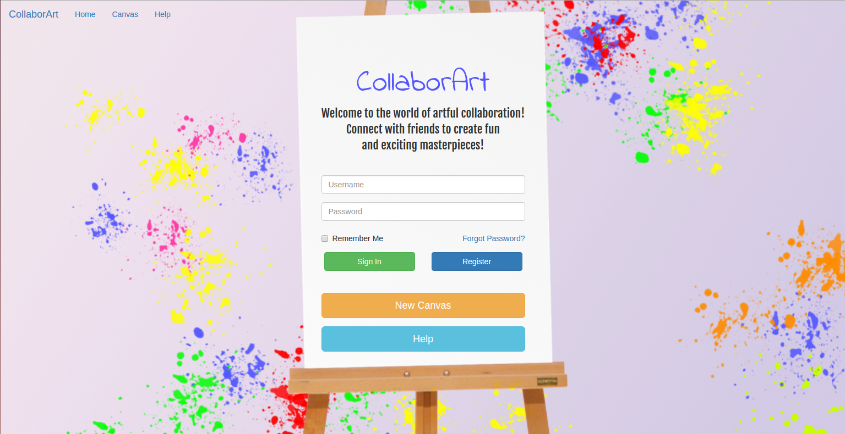

After registering/signing in to the website (minus the green ‘Registration Complete’ text):

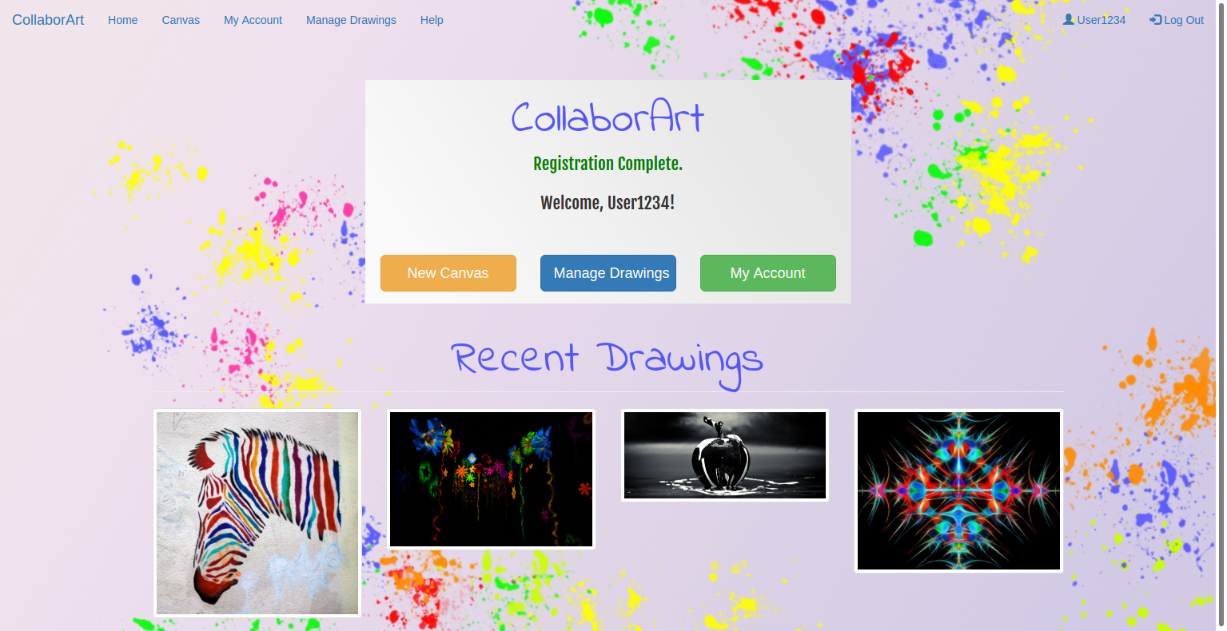

My account page (after edit buttons were clicked for password and email):

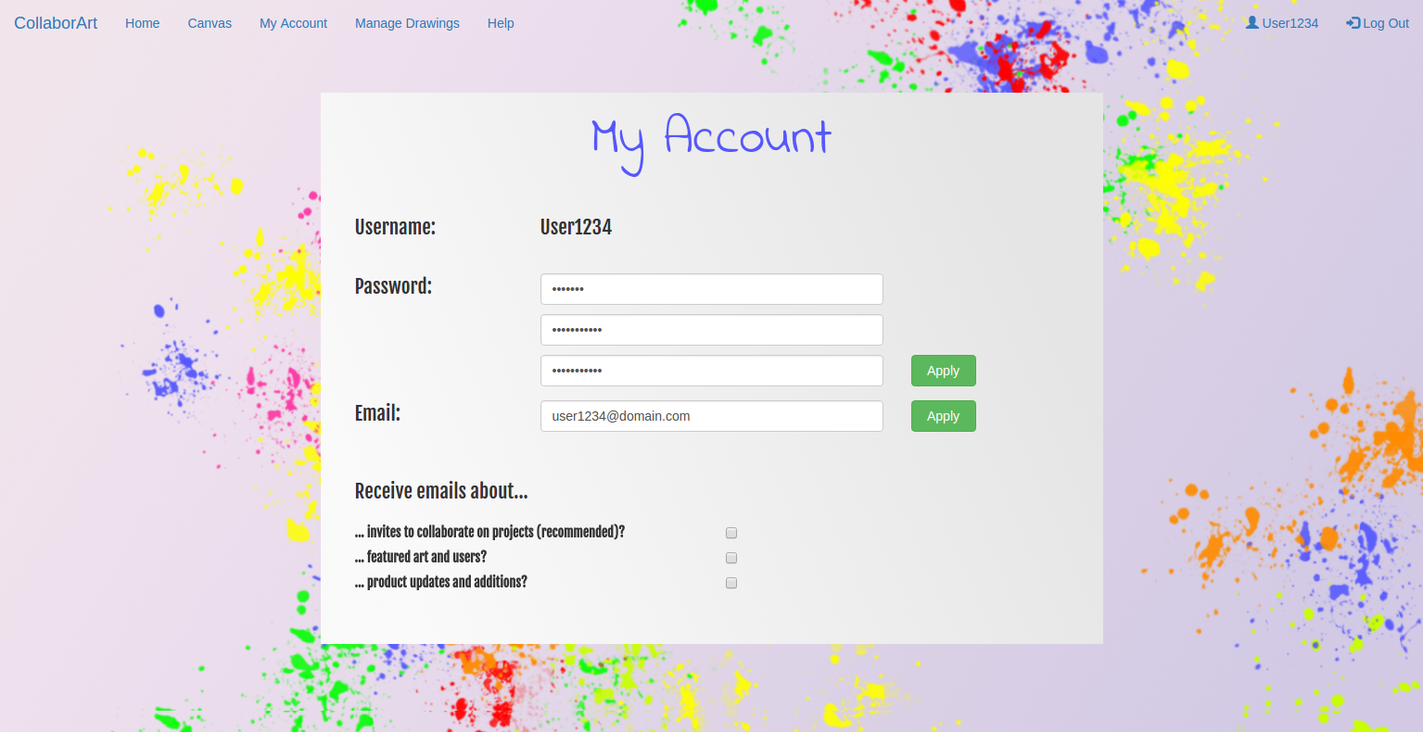

My account page (after email preferences were changed):

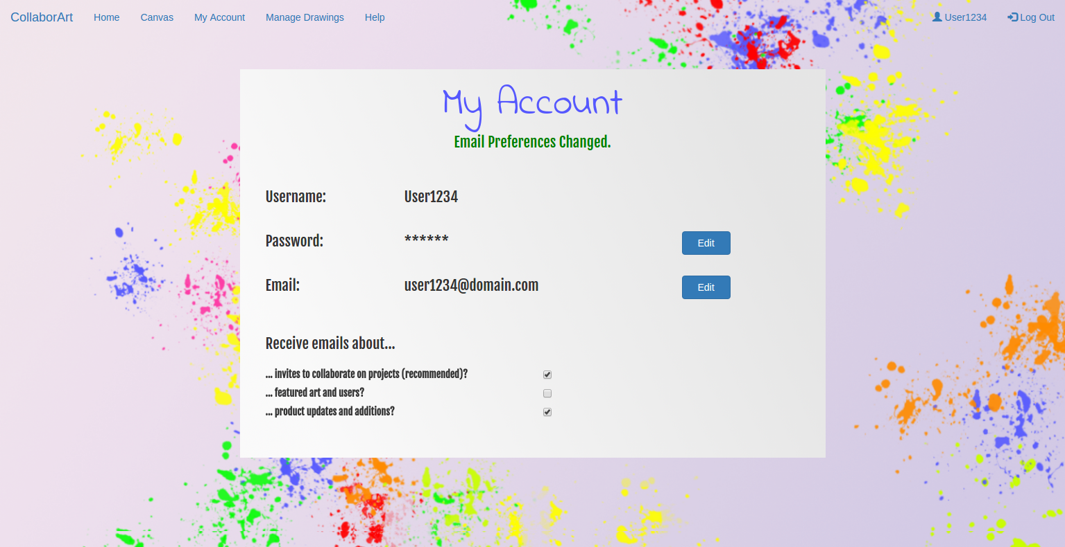

Canvas:

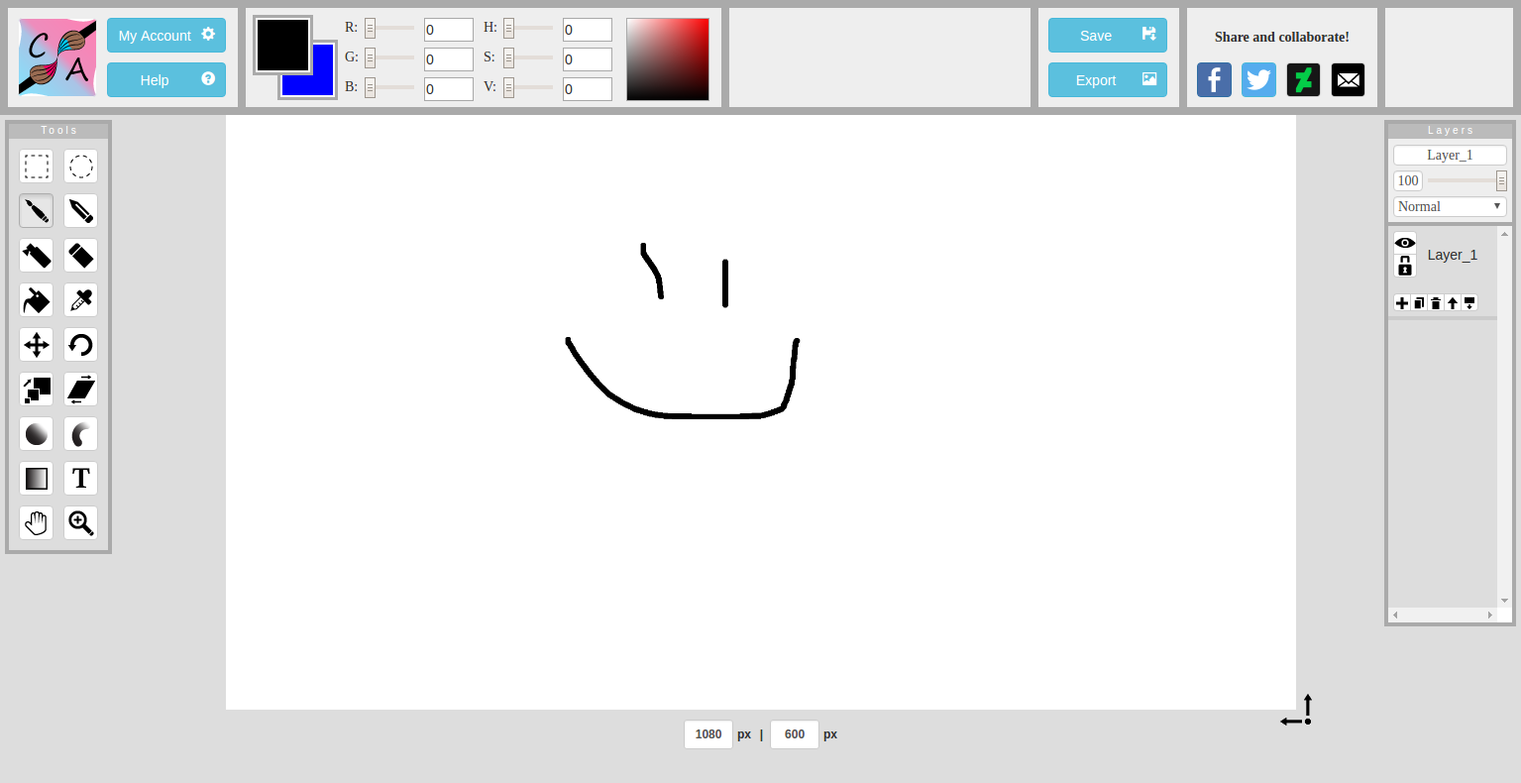

Manage drawings page:

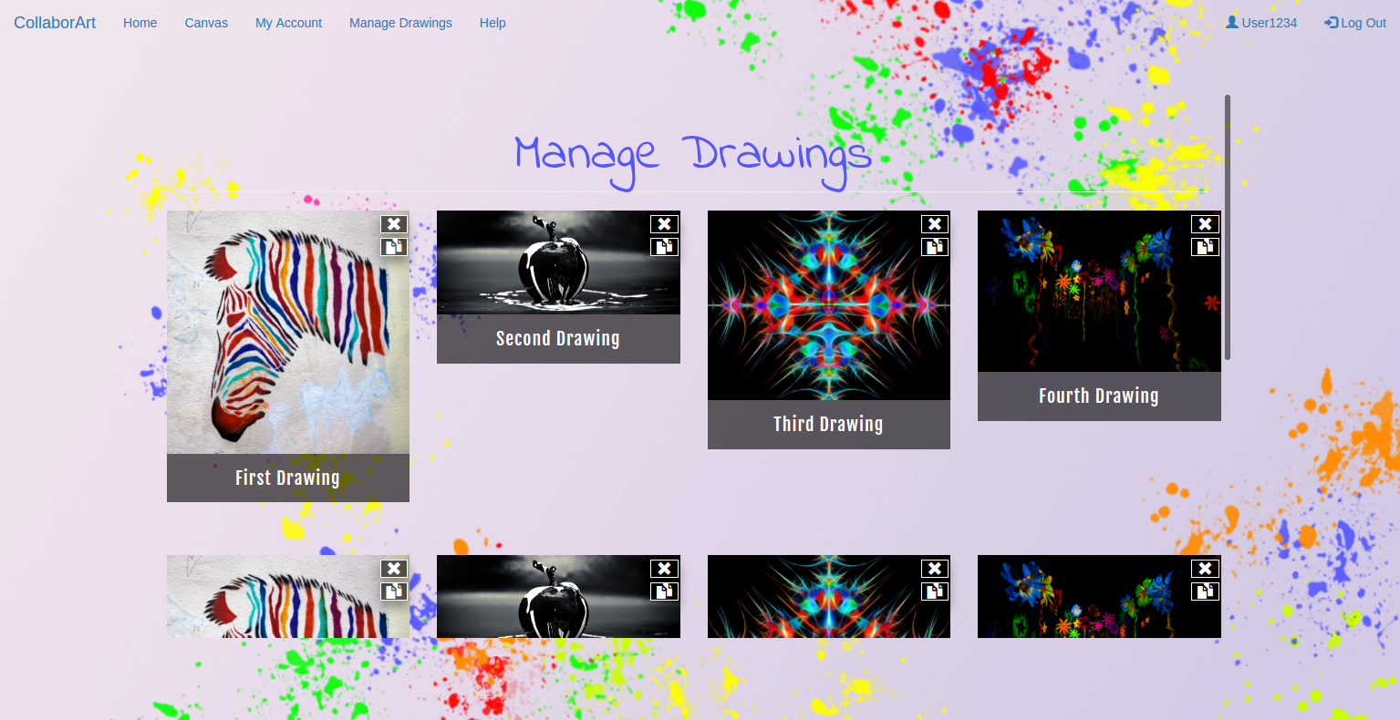

Manage drawings page (duplicated drawing and renaming):

